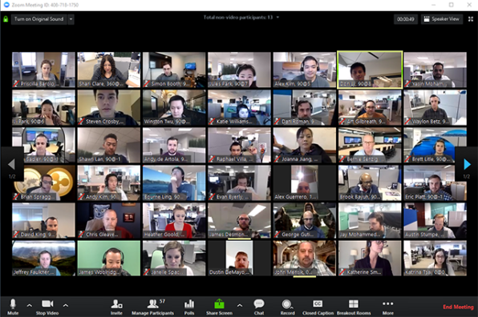
Authorized Lay Worship Leaders (NWPA Synod, ELCA)

RECTANGLE SCREEN
SYMPOSIUM

(formerly known as a
Round Table Discussion)

& YEARLY REVIEW

Saturday, March 6, 2021
9:30/10:00 a.m. – Noon
On Zoom

Pre-session Work
Complete your yearly review (attached to the email) and have it with you during our session. Also bring any concerns, questions, and joys of leadership with you for discussion. We’ll be using an Appreciative Inquiry method of conversation as a means of sharing experiences of serving during 2020.

The Agenda
Gathering for beverage and conversation: 9:30 a.m.
Session begins: 10:00 a.m.
Sending prayer: at Noon

RSVP
Email Pastor Sandra Jones (prskjones@gmail.com) or call 814-589-7660 to register by Monday, March 1. The Zoom link will be provided by email to those who register.

Please note the correct email address. As of February 15 all nwpaelca.org addresses will be disconnected.

